Cool Roof Tiles - Let's Prepare to face Summer

Cool Roof SRI (>90) tiles, a range of unique tiles that keeps the harsh rays of the sun off your building.

Recommended laying for terrace, balcony, and courtyard and beat the heat inside your home and save energy.

Cera has also developed cool roof and wall tiles which reflect sun rays thereby keeping the inside temperature cool and also save energy. It has devised a special process of glazing that makes the tiles reflect most of the solar heat. Explore the collection now!

Cera Cooling Tiles - Unique tiles that keep the sun rays off your building!

The upshots of an ingenious glazing process, these tiles help keep the room temperatures cool naturally and therefore helps reduce the load on external cooling appliances like your air conditioner or cooler. Now, imagine all the savings on your electricity bills while you sit cosily, within the cool comforts of your home. Lay them out onyour terrace, your balcony or exterior walls directly exposed to sunlight and they will continue to perform for years to come.

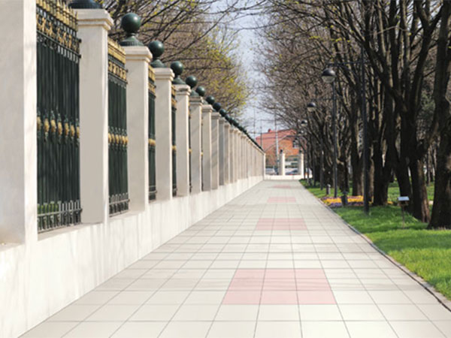

What is SRI?

* Solar Reflective Index (SRI) measures the surface's ability to reflect solar heat and emit infra-red heat.
* Endura Cool Roof SRI tiles reflect solar heat and emit absorbed radiation back into the atmosphere thus help keep the interiors of the building cooler.
* The U. S. Green Building Council’s LEED 2.2 uses SRI as a way to evaluate the surface’s capacity to reflect solar heat. The roof of the building needs to have a minimum SRI value of 78 to qualify for LEED accreditation.
* Endura Cool Roof SRI Tiles have SRI value > 90 (White Color).
* Endura Cool Roof SRI Tiles on the roof and facades of the building can reduce inside temperature by 10 to 15%.

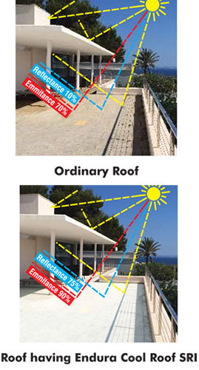

The Revolutionary Technology

With Endura, we have devised a special process of glazing that makes the tiles reflect most of the solar heat. The special glaze is composed of alumina silicate fine particles embedded with nanoparticles of zirconium silicate and zinc oxide admixtures, fired at very high temperature. The result is tile surface having a Solar Reflective Index (SRI) value above 90 (White Color).

Endura Cool Roof SRI tiles are offered in a satin matte finish that provides an anti-skid surface making them safe and practical for terraces, roofs, pavements, etc. They come in a convenient size of 30x30cm and thicknesses of 0.8cm for south India region, 1 cm rest of India and higher.\*

\*higher thickness is available on the made-to-order basis only.

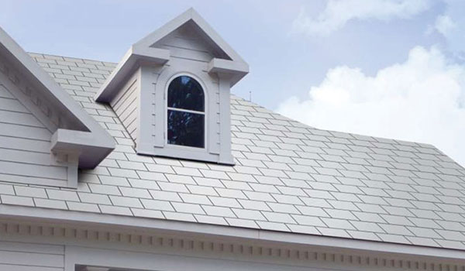

Benefits of Cera cool roof tiles

* Reduce the surface temperature by 10 to 15%
* Improve indoor comfort
* Reduce the cooling requirement and save electricity
* Reduce conduction of heat into the building
* Reduce the heat island effect in cities
* Reduction in global warming and saving of the ozone layer
* Endura Cool Roof SRI Tiles is a sensible choice for the buildings – saving electricity and saving the environment

Application Areas

* Building roofs
* Balconies
* Exterior facades cladding
* Pavements